Canopy position mediates climate sensitivity in Northeastern US Forests

M. Ross Alexander, Christine R. Rollinson, Alex W. Dye, David J.P. Moore, Valerie Trouet, Neil Pederson

Laboratory of Tree-Ring Research, The University of Arizona, Tucson, AZ

Harvard Forest, Harvard University, Petersham, MA

The Morton Arboretum, Lisle, IL

University of West Virginia, Morgan Town, MA

School of Natural Resources and the Environment, The University of Arizona, Tucson, AZ

*For submission to: Ecology Letters* (**5000 word, 6 Figure limit**)

**Abstract**

**Introduction**

Forests cover approximately 30% of the land surface, but are responsible for almost half of the terrestrial net primary productivity, making them an important reservoir of atmospheric carbon (Bonan 2008). The continued productivity and stability of forest ecosystems plays a pivotal role in current and future earth system processes. Future projections of forest growth indicate that these ecosystems are expected to experience reduced growth rates under changing climate conditions (D'Orangeville *et al.* 2016; Charney *et al.* 2016; Restaino, Peterson & Littell 2016). However, such projections are typically informed by targeted species inquiries that only capture the response of the upper most individuals in the canopy’s vertical profile (Williams *et al.* 2012; Charney *et al.* 2016) and may not accurately depict the stability of structurally complex ecosystems such as the temperate deciduous forests of the eastern United States (US). Eastern forests account for 45% of all forested area in the US (Oswalt *et al.* 2014) and are composed of multiple species arranged in stratified canopy layers. Forest growth is influenced by a combination of biotic and abiotic factors, such as climate conditions and competition (Fritts 1976, Cook 1985; Cook & Peters 1997; Kunstler *et al.* 2011) and the responses of individual trees to local conditions can have global scale consequences (Clark *et al.* 2012; Penuelas *et al.* 2013; Galván, Camarero & Gutiérrez 2014). Failing to account for the growth responses of individual trees from all canopy strata likely underestimates the stability of complex forest ecosystems in the face of changing climate conditions (Kovács, Tinya & Ódor 2017).

The canopy structure can greatly affect forest functioning, creating unique microclimate conditions (Kovács *et al.* 2017) that affect the climate-growth responses of canopy strata (Orwig & Abrams 1997; Carnwath, Peterson & Nelson 2012; Canham & Murphy 2016). Dense overstory canopies affect the shortwave radiation experienced by the understory constituents (Aussenac 2000) and insulate the forest against longwave radiation loss (Holbo & Childs 1987; Moore & Spittlehouse 2005). The difference in energy balance from the top to the bottom of the canopy allows for the proliferation of cold adapted species beneath thick overstory canopies (De Frenne *et al.* 2013; Kovács *et al.* 2017) providing unique light and successional conditions for shade-tolerant species (Ward & Stephens 1993; 1994; Onoda *et al.* 2013). The dense canopy created by overstory individuals also affects atmospheric mixing through the canopy profile, where the greatest shear occurs in the top 20% of the deciduous canopy profile (Baldocchi and Meyers 1988). This lack of mixing within the canopy creates unique microclimate conditions beneath the foliage that may not reflect the macroclimate conditions affecting the most dominant canopy stratum. The effect of microclimate conditions has been investigated for specific species (Lebourgeois *et al.* 2014; Canham & Murphy 2016) and in many different western coniferous and temperate European forests types (Martin-Benito *et al.* 2007; Gómez-Aparicio *et al.* 2011; Carnwath *et al.* 2012; Rozas 2015), but eastern temperate forests in the US have not received as much attention (Orwig & Abrams 1997; Canham & Murphy 2016).

Tree rings are often used quantify the growth relationships that exist between forests and the climate system (ex. Fritts 1976, Cook 1985). Traditional dendroclimate methodologies focus sampling on extreme sites where growth is regulated by very few climate factors. For example, temperature investigations are classically undertaken at high-elevation or high-latitude sites, where ring width co-varies strongly with temperature variability (Citations). This allows the researchers to limit the ecological influences on the sampled trees, resulting in a stronger temperature signal. However, these classic methodologies do not represent well the myriad of influences that affect tree growth in closed-canopied forests of the eastern US (Pederson et al. 2012). To effectively capture the climate-growth relationships in this region the sample size must be increased greatly, including multiple co-occurring species (Citations). The inclusion of multiple species provides a holistic perspective on forest response in these complex ecosystems have produced reliable growth-climate relationships and climate reconstructions for the eastern US (Maxwell *et al.* 2011; Pederson *et al.* 2012; Pederson et al. 2013, Martin-Benito & Pederson 2015; Maxwell, Harley & Matheus 2015).

To fully grapple with the challenges presented by changing climate conditions, our attention must turn away from species-specific inquiries and instead our approach should seek to understand the concerted forest response (Bonan 2007, Babst et al. 2017). Here we ask the question: does canopy position affect species specific climate-growth relationships across eight Northeastern US (NEUS) forests? We apply generalized additive models (GAMs) to conditionally assess the influence of temperature, precipitation, and moisture on the growth response of individual trees (Martin-Benito et al. ___) among the uppermost, intermediate, and understory representatives of four abundant NEUS tree species. We anticipate that the uppermost trees will show greater covariance with climate conditions, as they are not as heavily influenced by microclimate and ecological pressures as understory individuals.

**Methods**

*Sites description and climate data*

We sampled eight sites throughout the NEUS from Maine to west-central Massachusetts (Figure 1). Howland Forest (HO) is the northernmost site located in Maine. Gill Brook (GB) and Rooster Hill (RH) are higher-elevation sites located in the Adirondak Mountains of eastern NY state. Goose Egg (GE) is located in southwestern Vermont. North Round Pond (NR) and the Pisgah Tract (PS) are Harvard Forest land holdings that are located near one another. Two sites are located on the Harvard Forest property in west-central Massachusetts; the Lyford plots (LF) and the Harvard Forest tower plots (HF).

We extracted site-level mean temperature, precipitation, and maxiumum vapor pressure deficit data from the gridded PRISM climate data set, using bilinear interpolation (Daly, Taylor & Gibson 1997). We defined the growing season as May-September and all data presented are for this seasonal time period. With the exception of the two sites located in the Adirondak Mountains of eastern New York state, all sites represent similar growing season climate conditions (Figure 2). The RH and GB sites are found at higher elevations than the other sites, causing the deviations in Tmean and Precip. These proximal sites will serve to quantify the climate-growth relationships of trees in this area over a relatively broad range of climate conditions.

*Field techniques*

Two to three nested circular plots were established at each site to capture both stand structure and species composition differences among sites (Dye *et al.* 2016). In the innermost nest (0-13m) we sampled trees greater than 10 cm in diameter at breast height (1.37m; DBH), and in the middle nest (13.1-20m) we sampled trees greater than 20 cm in DBH, and in the outer nest (20.1-30m) trees greater than 30 cm DBH were sampled. Species, DBH and canopy position were recorded for each tree within the plots. Canopy classes were determined as follows: canopy trees composing the uppermost canopy layer (consisting of dominant and co dominant individuals), intermediate trees consisting of those trees clearly occupying space below the canopy of the dominant trees and above the lowest canopy layer, and understory trees being the lowermost strata recorded. Two increment cores were collected perpendicular from one another at DBH from each tree.

To compare the differences in annual growth climate responses between canopy strata, precise calendar dates were assigned to each growth ring. Increment cores were analyzed using dendrochronological techniques in which the cores were dried, mounted, and sanded to facilitate annual ring identification (Stokes and Smiley 1967). Rings were then assigned precise calendar dates through a combination of skeleton plots (Douglass 1941) and the list method (Yamaguchi 2011). Each ring was measured to the nearest 0.001mm, and visual dating was verified using COFECHA software (Holmes 1983; Grissino-Mayer 2001). Individual cores were crossdated within a species at each site and multiple cores collected from the same tree were combined to form the mean annual ring width for that tree. In the case where only one core from a tree could be verifiably dated, that singular radius was used to represent the growth for the entire tree. Trees in which none of the collected cores could be precisely dated were excluded from further analyses. A diameter reconstruction was then created for each tree by subtracting annual ring width increments from the DBH observed in the field (Davis *et al.* 2009; Dye *et al.* 2016). Ring-width measurements were transformed into basal area increment (BAI), as BAI considers the geometry of the tree and better illustrates productivity than traditional ring-width increments (Babst *et al.* 2014).

*Analytical techniques*

The above techniques resulted in over 1600 trees representing 22 different species. We selected the four best replicated species to conduct further analyses. Over 1000 trees representing *Tsuga canadensis, Quercus rubra, Fagus grandifolia,* and *Acer rubrum* across each canopy position are used in the following analyses (Table 1; Figure 1). We used a generalized additive model (GAM; Wood 2006) to quantify the influence of temperature, precipitation, vapor pressure deficit and diameter on dominant, intermediate, and understory trees of *Tsuga canadensis, Quercus rubra, Fagus grandifolia,* and *Acer rubrum* (Table 1; Figure 1). The GAM framework allows for non-linear trends in the data to emerge without having to prescribe an *a priori* functional form (Martínez-Vilalta *et al.* 2008; Polansky & Robbins 2013; Peters *et al.* 2015). Several models were created to determine a parsimonious balance between canopy position, species, and climate factors. This approach conditionally fits the influence of the climate variables and diameter on individual trees. Including diameter as a predictor variable accounts for the effects of size on tree growth without having to detrend the series *a priori* (Peters *et al.* 2015). We created models to test the effects of the combination of growing season mean temperature and growing season (May - Sept) precipitation and also models investigating growing season maximum vapor pressure deficit. Within this framework we blocked the trees by species, canopy position, and an additive approach of both canopy position and species, respectively.

Natural log-transformed BAI was predicted using three-knot thin-plate regression splines fit by first canopy class and the climate variables and diameter. The number of knots indicates the rigidity of the spline, and natural log-transformed BAI was used to meet normality assumptions. To capture possible growth-release events that are common in closed-canopy forests (Lorimer & Frelich 1985, 1989), we also fit a year effect using a four-knot thin-plate regression spline fit by plot. The flexible four-knot spline was used to more accurately capture the year-to-year changes that can occur due to release events that may vary among plots at a single site. Fixed intercepts of site, plot ID, species, canopy class, tree ID were also included in each model. A null model that did not differentiate between either species or canopy strata was also run as a baseline for comparison.

GAMs produce a continuous response curve for each species across each canopy class across the range of temperature, precipitation, and VPDmax (Figure 3). These response curves display the effect that climate conditions and tree size (Figure 5) have on the BAI. Differences in climate and size sensitivities were assessed by comparing the mean slopes and the 95% confidence intervals around each effect (Rollinson et al. in press).

**Results**

The additive

**Table 1.** Sample breakdown of trees by species within each canopy strata.

|  |  |  |  |  |  |
| --- | --- | --- | --- | --- | --- |
| Canopy Class | ACRU | FAGR | QURU | TSCA | Total |
| Dominant | 76 | 61 | 213 | 339 | 689 |
| Intermediate | 47 | 47 | 48 | 54 | 196 |
| Understory | 42 | 40 | 15 | 103 | 200 |
|  |  |  |  | **Total** | 1085 |

**Table 2.**  AIC comparisons for all canopy class (CC), species (Spp) and combined canopy class and species (CC x Spp) comparisons. Models are arranged from lowest AIC-value (most parsimonious) to highest AIC-value, with the most parsimonious model represented in bold. The difference of each AIC value from the most parsimonious is also presented.

|  |  |  |
| --- | --- | --- |
| Model | AIC | Difference |
| Temp x Precip CC x Spp | **321149.2** | 0 |
| Temp x Precip Spp | 321525.5 | 376.3 |
| VPDmax CC x S | 321760.8 | 611.6 |
| Temp x Precip CC | 322200.4 | 1051.2 |
| Temp x Precip null | 322729.4 | 1580.2 |
| VPDmax null | 322733.5 | 1584.3 |

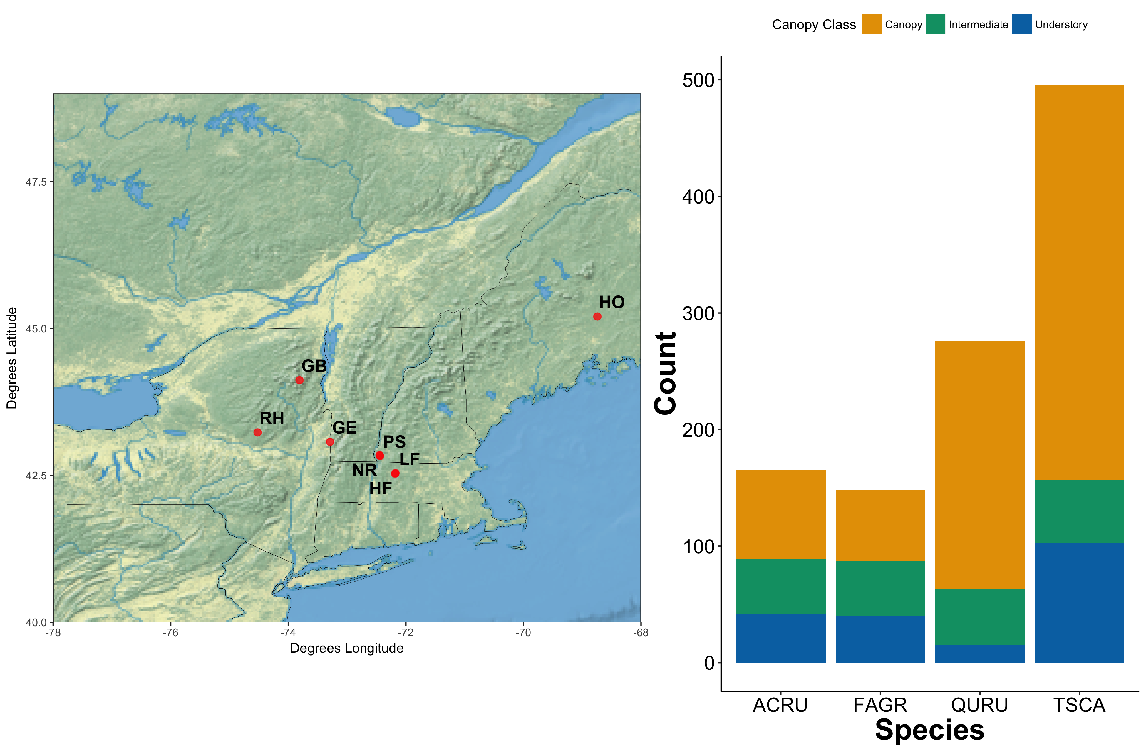

Figure 1. Map of sites with stacked barplots

* Maybe do A/B panels if overlay of barplots doesn’t work

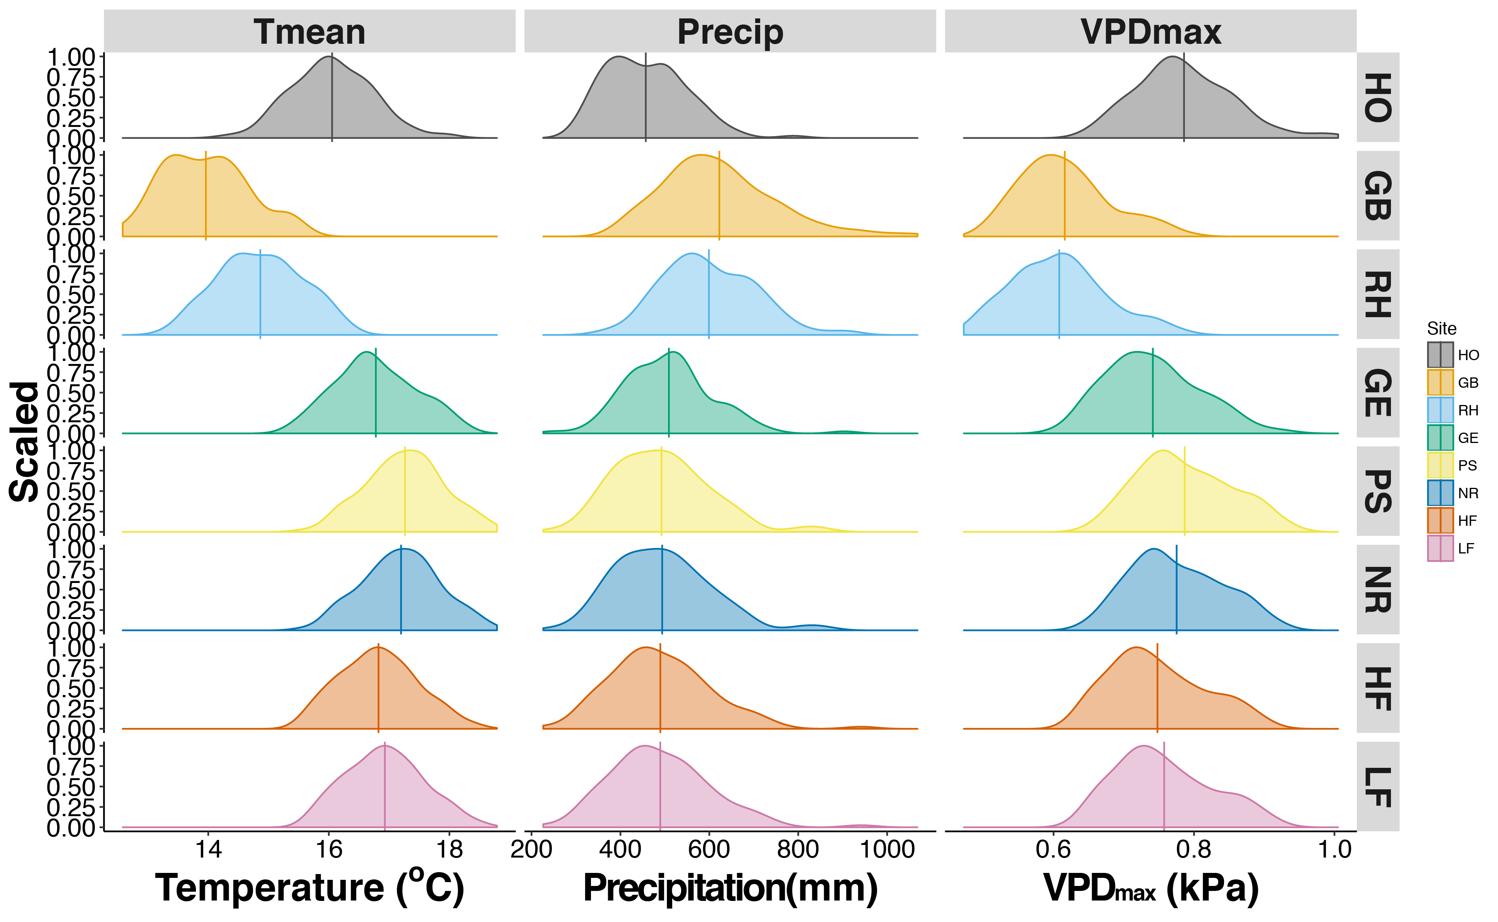

Figure 2. PDF of climate conditions—Tmean/precip/VPD

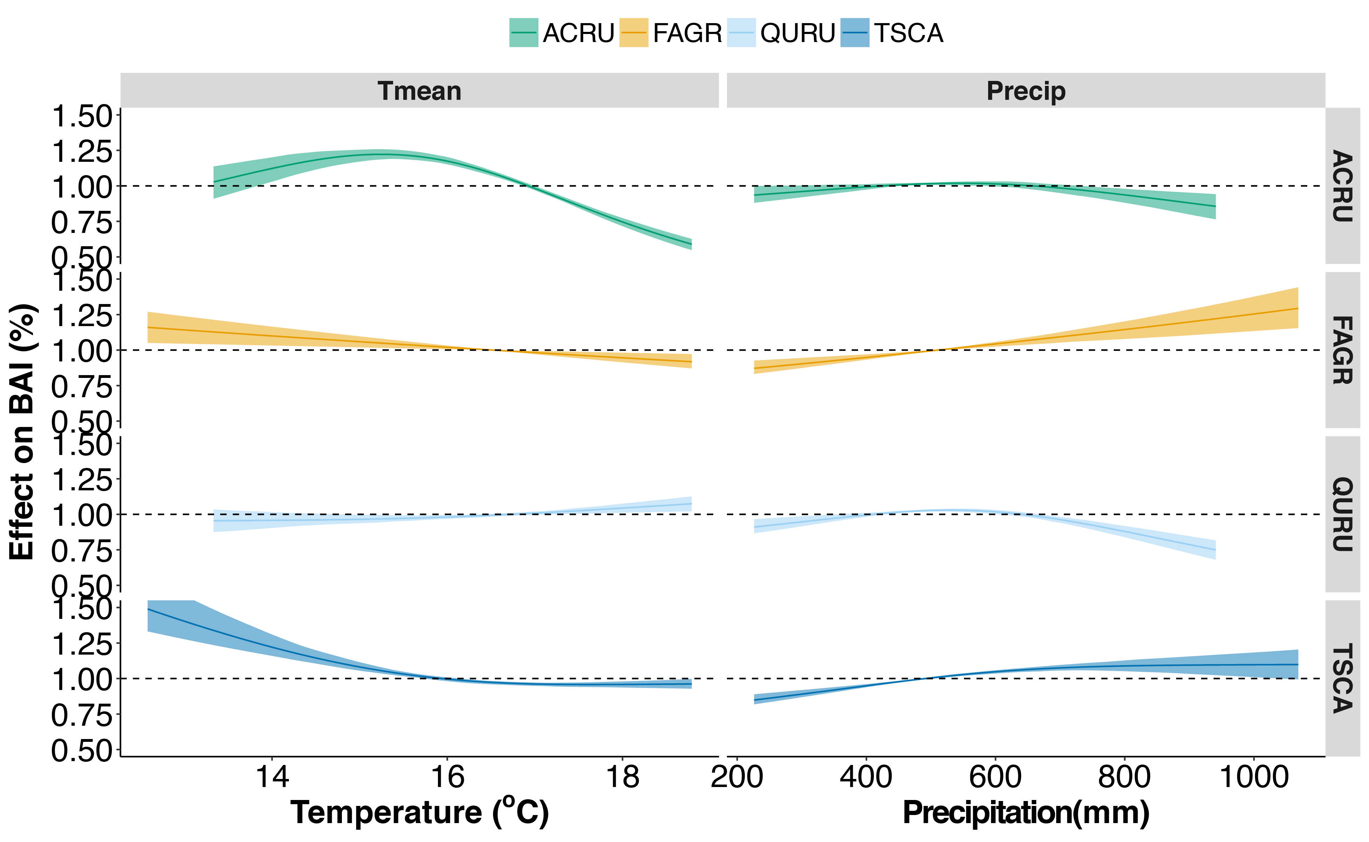

Figure 3. Species-only sensitivity curves.

* **Interpretation Guidelines (All GAMs)**
  + Looking at the instantaneous slope (1st derivative) of each curve
  + Slope = for every change in degree temperature or mm precipitation, you see an X percent increase/decrease in growth

**Figure 3 Results:**

* **Summary**
  + Of your species here, QURU is the only one with a mean positive growth, which makes sense because it’s your species associated with warmer, drier sites
  + Strongest temperature responses seen in ACRU & are split between positive & negative (classic niche shapes)
  + Strongest precip response seen in QURU when precip >550 mm/yr (negative effect)
  + Apparent trade-offs in temperature response of ACRU & QURU:
    - ACRU effects of temperature on ACRU growth decreases starting at 15.5˚C, but becomes positive for QURU at 15.8˚C
    - The two are similar in precipitation responses, although QURU is more sensitive
* **Species Details**
  + **ACRU**
    - Temperature
      * Mean Slope (whole range) = -0.0716 (SD = 0.18) % BAI / ˚C
      * Non-significant Slope from 14.9-15.5 ˚C
        + Slope <14.9˚C = 0.123 (0.030)
        + Slope >15.5˚C = -0.222 (0.085)
    - Precipitation
      * Mean slope (whole range) = -2.29e-4 (4.1e-4) % BAI/mm
      * Non-significant slope: 405 - 609.1 mm/yr
        + Slope < 405 mm/yr: 3.2 e-4 (1.77 e-5)
        + Slope > 609 mm/yr: -5.7 e-4 (1.5 e-4)
  + **FAGR**
    - Temperature
      * Mean Slope (whole range): -0.0378 (2.82 e-7)
        + Very small SD indicates nearly linear slope
      * Non-significant slope: none; slope of whole range significant and nearly linear
    - Precipitation
      * Mean Slope (whole range): 4.56 e-4 (1.8 e-5)
        + Small SD indicates also nearly linear
      * Non-significant slope: none
  + **QURU**
    - Temperature
      * Mean Slope (whole range): 0.018 (0.014)
      * Non-significant slope: all < 15.8 ˚C
        + Slope > 15.84 ˚C: 0.032 (0.0054)
    - Precipitation
      * Mean Slope (whole range): -4.13e-4 (6.83e-4)
      * Non-significant slope: 498.5 – 549.6 mm/yr
        + <498 mm/yr: 4.36 e-4 (1.06 e-4)
        + > 550 mm/yr: -9.08 e-4 (3.26 e-4)
  + **TSCA**
    - Temperature
      * Mean Slope (whole range): -0.0717 (SD 0.0575)
      * Non-significant slope: >17.1 ˚C
        + <17.1˚C : -0.098 (0.044)
    - Precipitation
      * Mean Slope (whole range): 3.01 e-4 (2.55 e-4)
      * Non-significant slope: > 685.7 mm/yr
        + < 685.7 mm/yr: 5.10 e-4 (1.47 e-4)

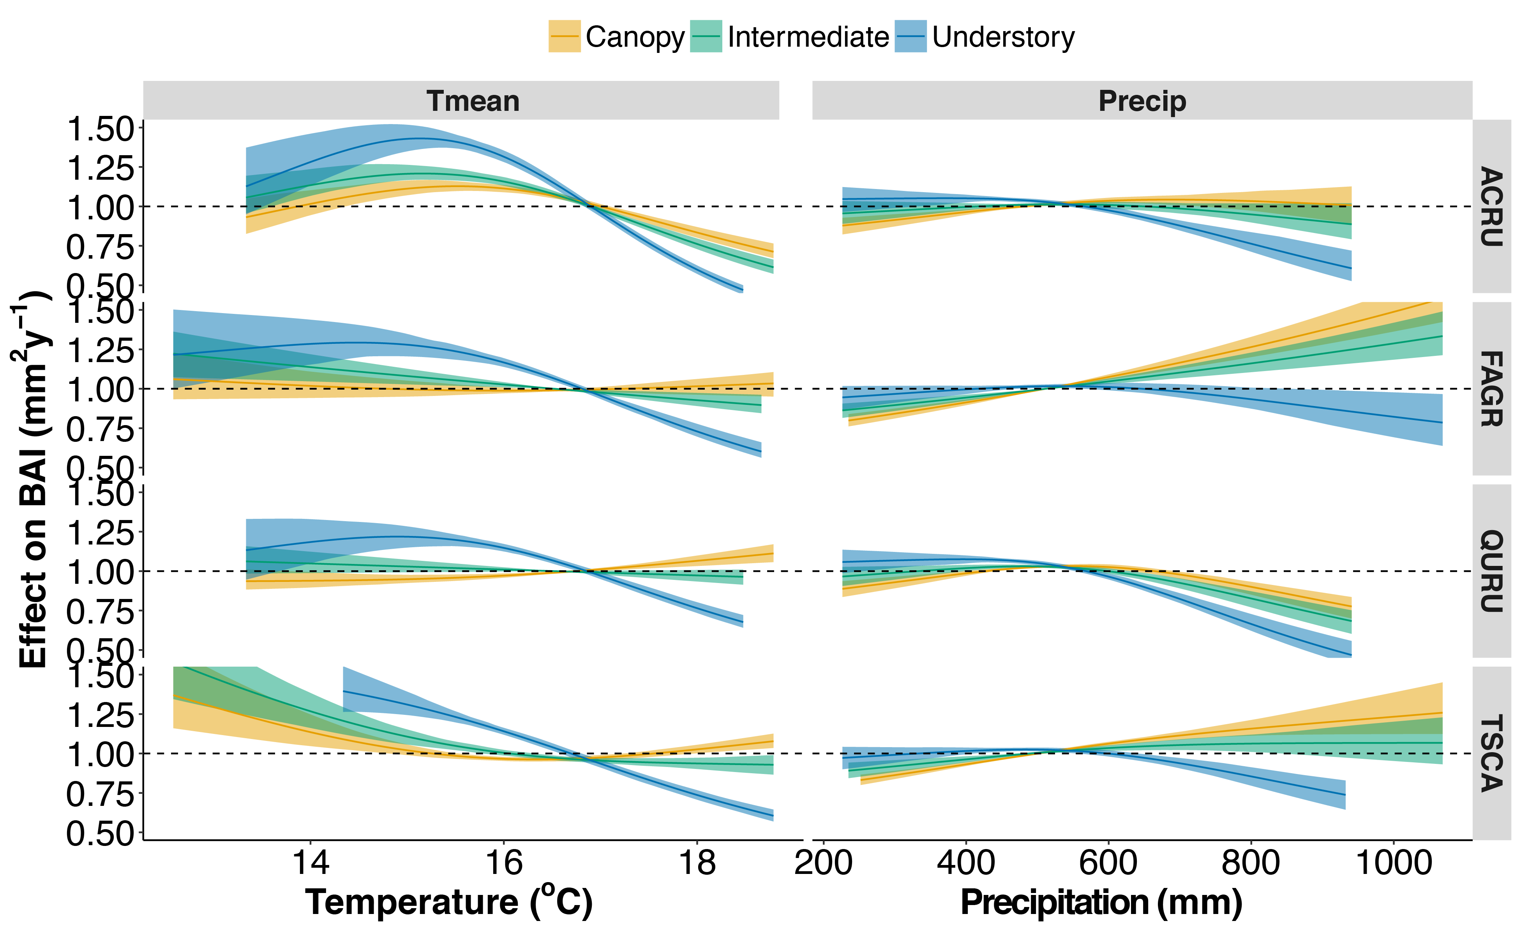

Figure 4. Climate sensitivity curves—Tmean/precip

**Figure 4 Results:**

* Analysis Methods Summary
  + Overall canopy class effects via mixed effects model with random species slopes:
    - lme(mean ~ tmean*Canopy.Class -tmean - Canopy.Class, random = ~1 + Canopy.Class|Species, data=cc.deriv[cc.deriv$var=="tmean", ])
  + Within species comparison: linear model over entire range of climate
* **Results Summary**
  + *Overall*, canopy class doesn’t change the slope of climate response, but exacerbates the underlying pattern
  + ***Temperature responses: at least twice as sensitive and always negative, which is sometimes in opposite the canopy***
    - In the upper half of the observed temperature range, understory ACRU is 2.67 times more sensitive to temperature than the canopy trees
    - For FAGR, canopy is not-temperature sensitive, but understory shows temperature sensitivity is strongly negative
    - Above 15.4 (so upper half): QURU goes from weakly positive in canopy to strongly negative in understory
    - TSCA canopy trees show negative effect of temperature from 12.58 to 16.1˚C and the slightly positive above 16.6˚C, but understory is consistently negative
      * Even when accounting for this reversal (by using the absolute value of the slope), understory is 2.2 times more sensitive
  + ***Precipitation responses:***not as consistent as temperature, but also generally stronger and more negative impacts of precip on understory growth than canopy; in FAGR, this just means no precip sensitivity even though canopy is strongly positive
    - ACRU shows a reversal from non sig/slightly pos to significantly negative
    - FAGR also shows a reversal, but going from strongly positive across the range of precip in the canopy to weakly negative in the understory
    - QURU growth reductions at higher precip are 2.6 times higher for understory than canopy
    - TSCA sees shift from moderately positive in canopy trees to moderately negative in the understory
* **Overall Canopy Class Details**
  + Mixed effects model to look at effect of canopy class given species effect
    - Temperature:
      * Tmean*Canopy: mean = -0.0013 (SE = 0.00224, p =0.54)
      * Tmean*Intermed: mean=-0.0130 (SE = 0.00224; p<0.001)
      * Tmean*Understory: mean=-0.0829 (SE = 0.00224; p<0.001)
    - Precipitation
      * Precip*Canopy: mean= -1.114 e-6 (SE 5.59 e-8; p<0.01)
      * Precip*Intermed: mean= -1.114 e-6 (SE 5.59 e-8; p<0.01)
      * Precip*Understory: mean= -2.807 e-6 (SE 5.59 e-8; p<0.01)
* **Species Details**
  + **ACRU**
    - Temperature: Canopy inflection point = 14.53 – 15.72 ˚C
      * <14.5˚C:
        + Canopy: 0.0084 (SE 0.000501; p<0.001)
        + Intermed: 0.0068 (SE 0.000501; p<0.001)
        + Understory: 0.0121 (SE 0.000501; p<0.001)
      * >15.72:C
        + Canopy: -0.0089 (SE 0.000569; p<0.001)
        + Intermed: -0.0127 (SE 0.000569; p<0.001)
        + Understory: -0.0238 (SE 0.000569; p<0.001)
    - Precipitation:
      * Overall
        + Canopy: 6.023 e-8 (SE 4.362e-8; p=0.168)
        + Intermed: -3.525e-7 (SE 4.362e-8; p<0.001)
        + Understory: -1.58e-6 (SE 4.362e-8; p<0.001)
      * canopy only sensitive <600.6 mm/yr
        + Canopy: 9.537e-7 (SE 6.89 e-8; p<0.001)
        + Intermed: 2.554e-7 (SE 6.89 e-8; p<0.001)
        + Understory: -5.498e-7 (SE 6.89 e-8; p<0.001)
  + **FAGR**
    - Temperature (whole range)
      * Canopy: -0.00011 (SE 0.000432; p=0.795)
      * Intermed: -0.00311 (SE 0.000432; p<0.001)
      * Understory: -0.00829 (SE 0.000432; p<0.001)
    - Precipitation (whole range)
      * Canopy: 1.093e-6 (SE 3.845e-8; p<0.001)
      * Intermed: 6.804e-7 (SE 3.845e-8; p<0.001)
      * Understory: -5.473e-7 (SE 3.845e-8; p<0.001)
  + **QURU**
    - Temperature: canopy non-sig below 15.4˚C
      * >15.4˚C
        + Canopy: 0.00375 (SE 0.000252; p<0.001)
        + Intermed: -0.000959 (SE 0.000252; p<0.001)
        + Understory: -0.01141 (SE 0.000252; p<0.001)
    - Precipitation: canopy non-sig 524-575 mm/yr
      * Canopy: -1.069e-6 (SE 2.463e-8; p<0.001)
      * Intermed: -1.428e-6 (SE 2.463e-8; p<0.001)
      * Understory: -2.736e-6 (SE 2.463e-8; p<0.001)
  + **TSCA**
    - Temperature: canopy non-sig 16.1-16.6˚C
      * Overall mean
        + Canopy: -0.002021 (SE 0.0004411, p<0.001)
        + Intermed: -0.005019 (SE 0.0004411, p<0.001)
        + Understory: -0.010195 (SE 0.0004411, p<0.001)
      * Absolute value (to account for sign change)
        + Canopy: 0.00466 (SE 0.0003675; p<0.001)
        + Intermed: 0.00501 (SE 0.0003675; p<0.001)
        + Understory: 0.01020 (SE 0.0003675; p<0.001)
    - Precipitation: canopy non-sig above 1001 mm/yr
      * Overall:
        + Canopy: 6.941e-7 (SE 5.495e-8 p<0.001)
        + Intermed: 2.519e-7 (SE 5.495e-8 p<0.001)
        + Understory: -9.826e-7 (SE 5.495e-8 p<0.001)

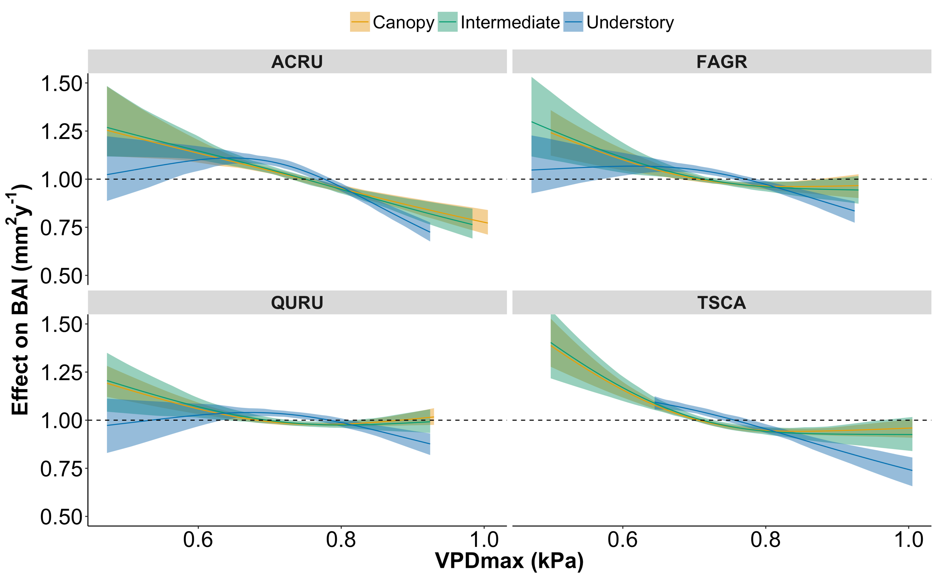

Figure 5. Climate sensitivity curves—VPD/drought index

**Figure 5 Results:**

* Analysis Methods Summary
  + Overall canopy class effects via mixed effects model with random species slopes:
  + Within species comparison: linear model over entire range of climate
* **Results Summary**
  + *(ad hoc; no quantitative yet: little to no effect of canopy class on VPD response)*
    - There has to be a cool interpretation here, but I’m too brain dead right now to figure it out
* **Overall Canopy Class Details**
  + Mixed effects model to look at effect of canopy class given species effect
* **Species Details**
  + **ACRU**
  + **FAGR**
  + **QURU**
  + **TSCA**

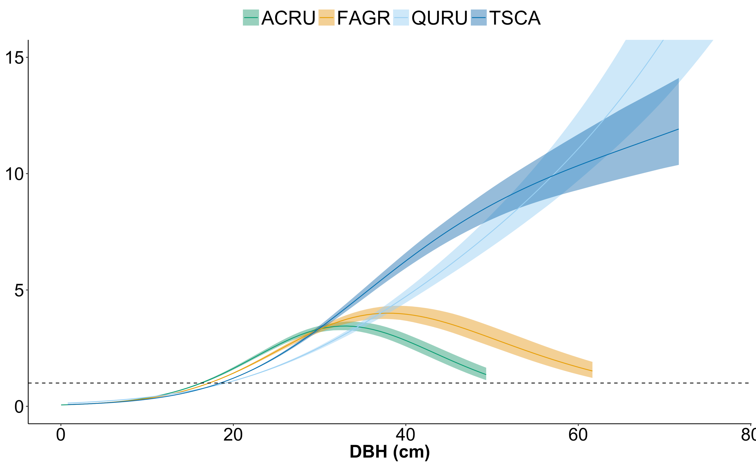

Figure S1 Species Size effects

**Discussion**